Analysis & Insights:
- What is the total revenue generated?
Insights: The amount of total revenue received is 15263601.45. It shows the performance of the firm as a whole and can act as a standard measure to gauge future growth. An increase or decrease in its value is indicative of shifts in demand, pricing, or customer behaviour.
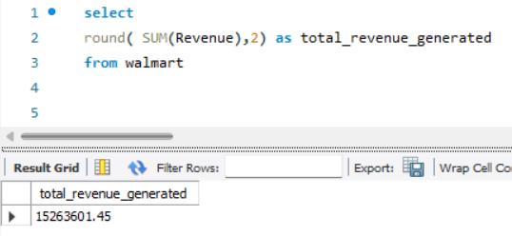

- How many total transactions were completed?
Insights : total 5000 transactions were completed, this helps measure customer activity and demand.
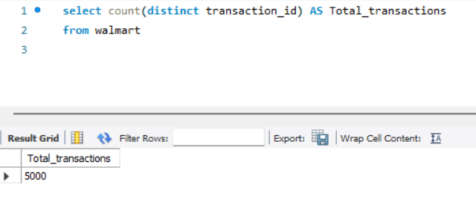

- What is the average order value?
Insights : The average order value (AOV) from any order placed by the customer is ₹3052. The higher the AOV, the more successful the sales are through upselling or buying an expensive product.
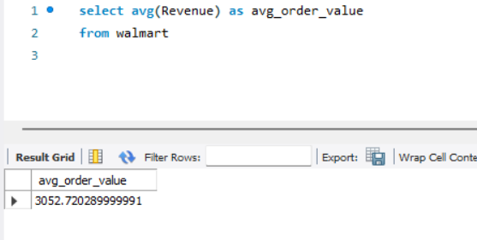

- Which Product Categories Generate the Most Revenue?
Insights: The highest amount of money earned from any category comes from the Electronics category which is 7941631.8. This shows a very high demand for the products in the Electronics category and implies that more promotions can earn more revenue for this category.
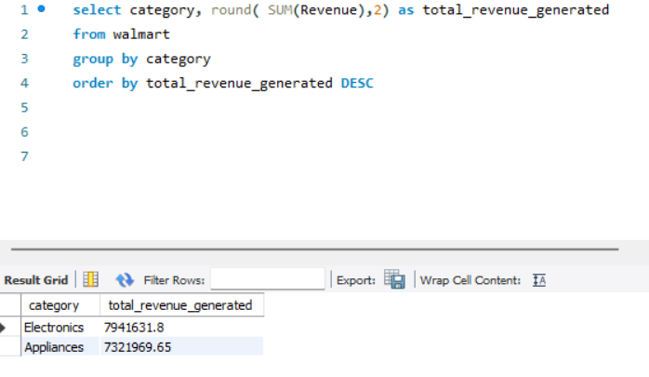

- Which products generate the highest revenue?
Insight: TV is the best performing product, earning ₹2049493.86 in sales. The product has high customer demand, and there is potential for increasing inventory levels, adjusting prices, or launching complementary products. 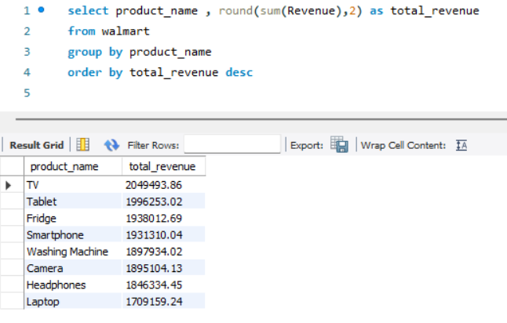

- What are the top 5 best-selling products by quantity?
Insight: The best-selling products, in terms of quantity sold, are Fridge, Tablet, TV. These products have high demand. However, high quantity sold does not imply high sales; therefore, price consideration needs to be taken into account.
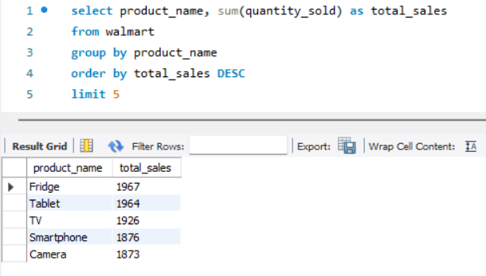

- Which store locations generate the highest revenue?
Insights: The Store 17 in Dallas, TX branch has the highest sales, earning ₹213954.02. The branch has shown good regional performance and can act as a standard for other branches.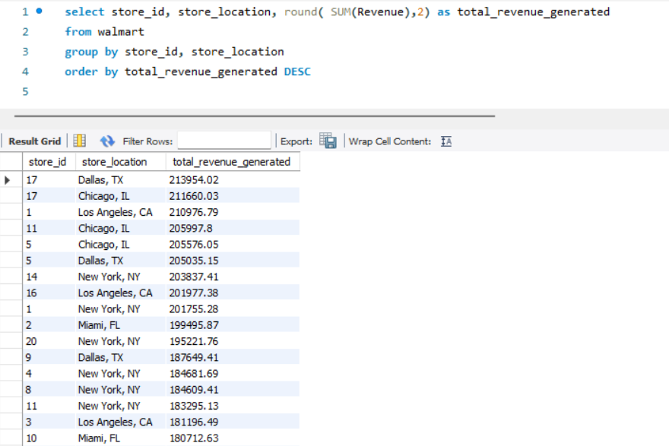
- What Are the Monthly Sales Trends?
Insights: Sales reach their peak in AUG, which implies that demand is influenced by seasons (such as holidays). Companies need to build up their inventories and marketing strategies during peak seasons.
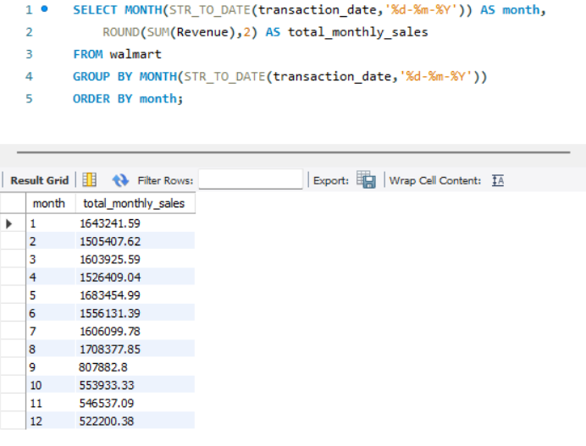

- Which days of the week generate the most revenue?
Insights: Thursday is the day when sales are at their peak, which implies that this is the day when most people shop. This information can be used for optimizing manpower and marketing strategies.
Sales peak on Thursdays, suggesting an opportunity to optimize staffing, inventory allocation, and promotional campaigns on high-demand days.
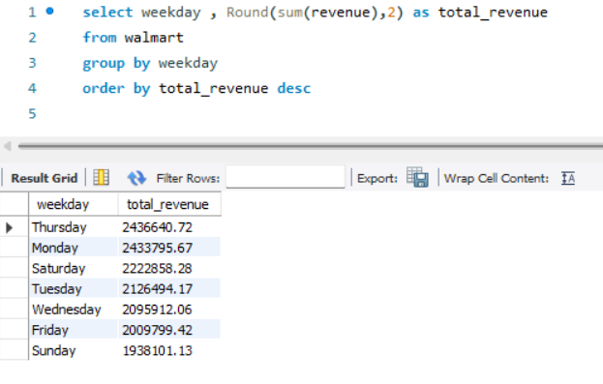

- How do daily transaction volumes vary over time?
Insights: Daily transaction volumes fluctuate without a consistent trend, indicating variability in customer demand and potential influence of external factors.
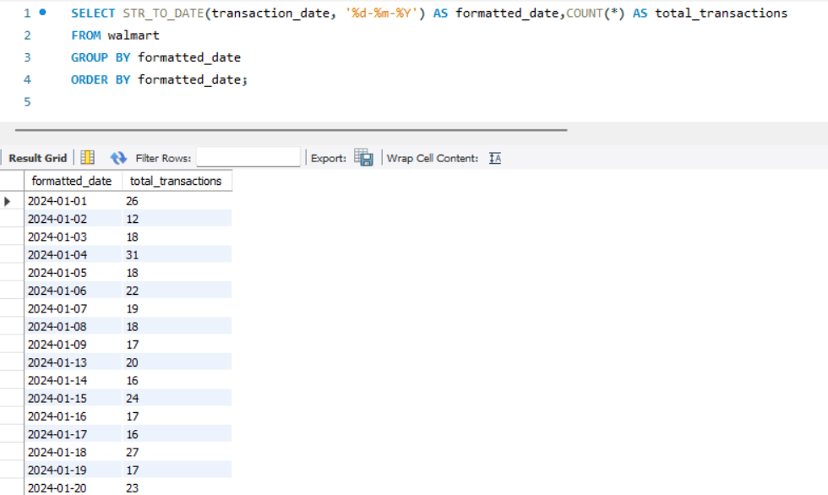

- Do Loyal Customers Spend More Than Regular Customers?
Insights: Platinum customers generate a revenue of ₹4012963.14, while gold customers generate ₹3536863.54. This indicates that loyal customers have a higher lifetime value, implying that their retention is crucial
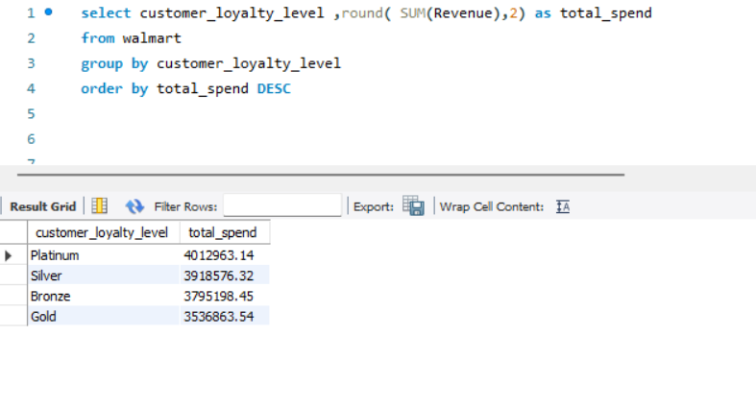

- Which age group contributes the most revenue?
Insights: The age group of 31-40 generates the maximum revenue ₹2981156.08. They can be marketed to earn more revenues.
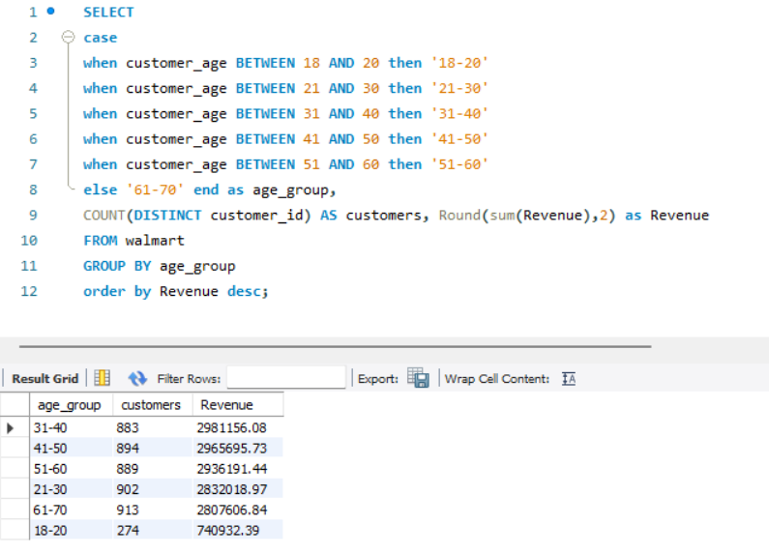

- How does customer gender influence purchasing behavior?
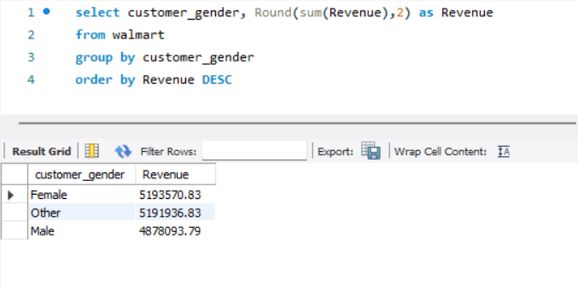
Insights: Female customers generate the highest revenue ₹5193570.83 . This indicates that Female customers have distinct buying habits. This can be used for marketing them.

- Which income group contributes the most revenue?
Insights: The High Income generates the highest revenue. This implies that purchasing power greatly impacts sales. Expensive products can be sold to this income group.
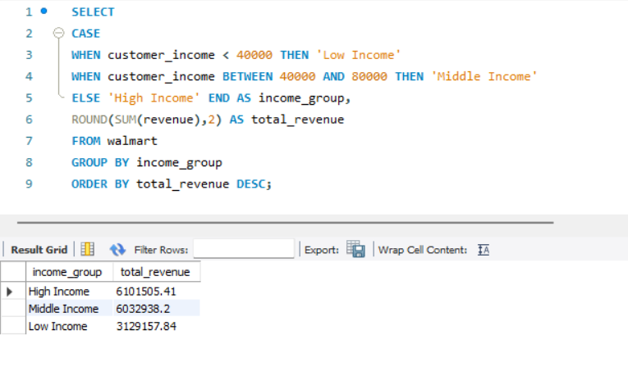

- Which Payment Method Is Most Frequently Used?
Insights: The Credit Card option has been the most frequent choice by customers, thus pointing out their preference for this payment method. Discounts or other incentives offered with respect to this payment mode may increase the sale figures even further.
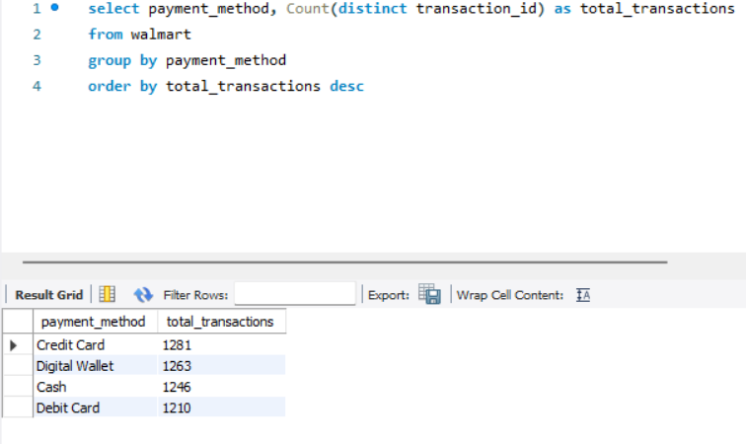

- Do Promotions Actually Increase Sales?
Insights: Revenue generated during promotions ₹8062411.03 is greater than those during non-promotions ₹7201190.42. The results suggest that the promotions have been effective in boosting revenue. Promotions generate slightly higher revenue than non-promotional sales, indicating moderate effectiveness. However, the increase is not significant, suggesting scope for optimization.
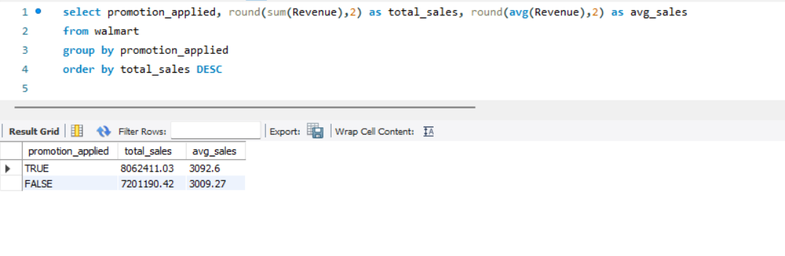

- Which Promotion Type Generates the Highest Demand?
Insights: Promotion types do not show a strong impact on demand, indicating that factors such as product value and customer preference may play a larger role.
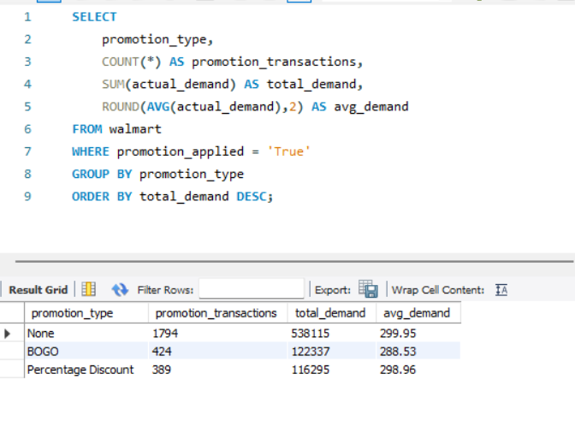
- How much revenue is generated during promotions?
Insights: Revenues from promotions are percentage discount and BOGO are 2400750 and 2534988 respectively.
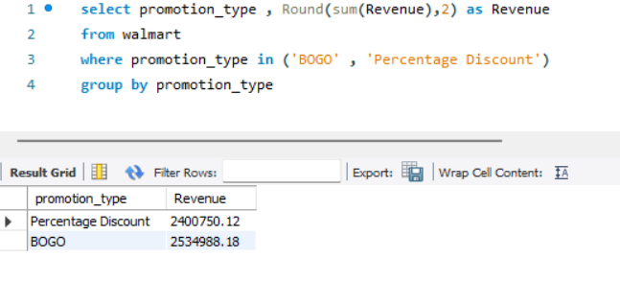

- What is the overall stockout rate?
Insights: Stockouts occur at a rate of 51.86 %. This means there are too few products available. The higher the stockout rate, the less effective the inventory management.
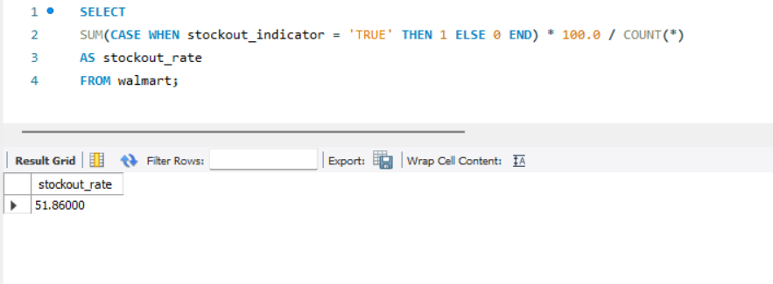
- Which products frequently experience stockouts?
Insights: The product with the highest number of stockouts is product id 776 i.e Smartphone There seems to be very high demand for these products, but not enough supply. More products need to be ordered.

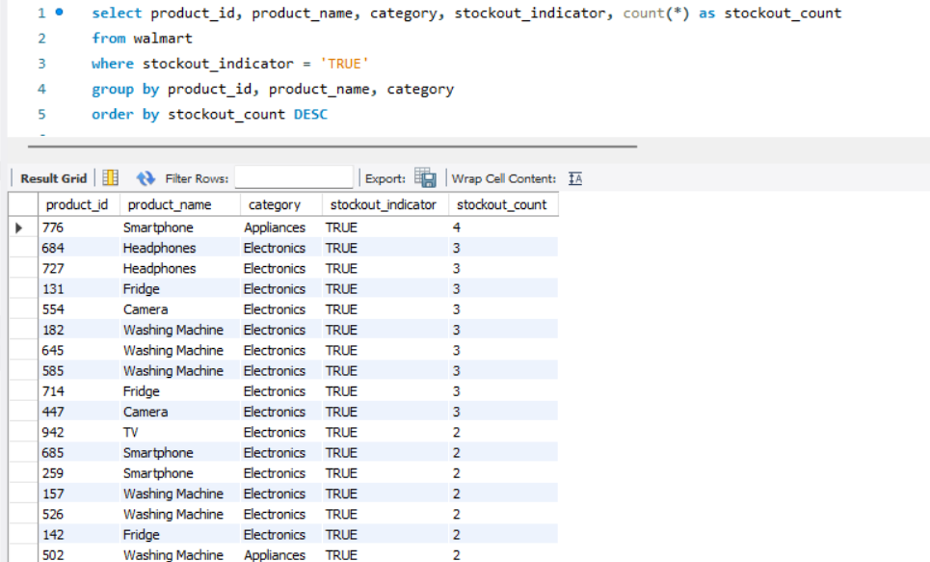

- Which Stores Have the Highest Stockout Rates?
Insights: The store with the highest stockout rate is store 14 New York, NY.
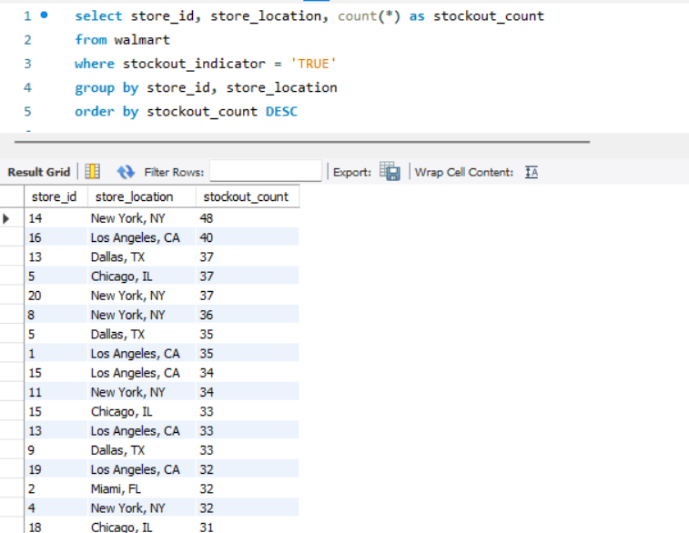

- What Is the Average Demand When Stockouts Occur?
Insights: On average, the demand for each stockout incident is 300 units.
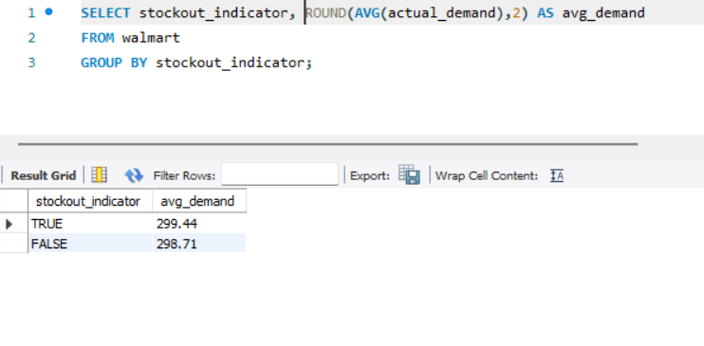

- What are the key business performance metrics (total revenue, total quantity sold, total transactions, and average order value)?
Insights0: There were a total number of 5000 transactions from which the total revenue obtained was ₹15263601.44. With a total number of 14914 items sold, there was an average order value of ₹3052.72. The average order value shows the size of the business operation, whereas the revenue gives an indication of how much is being made through selling goods. The large average order value shows effective pricing and packaging of products, whereas the total quantity shows high demand.

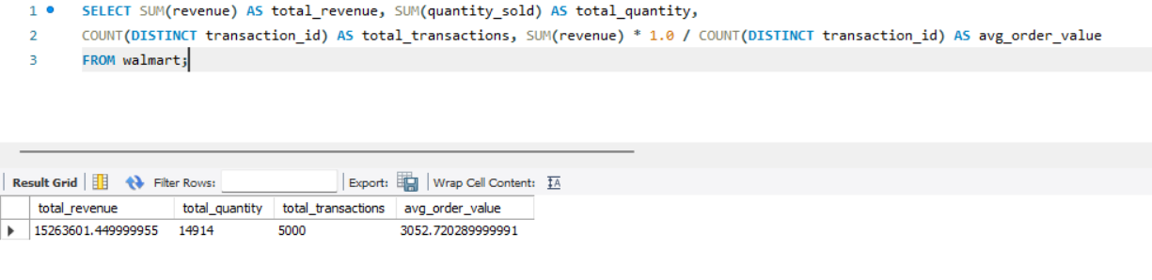

- How do stockouts impact potential sales and which products are most affected?
Insights: A considerable amount of inventory was out of stock, thereby causing a loss of units and potentially a revenue loss as below for each product category. This shows a definite effect of inadequate inventory levels on business performance. Items that contributed to a larger lost potential revenue show the business areas with huge opportunities for revenue loss.
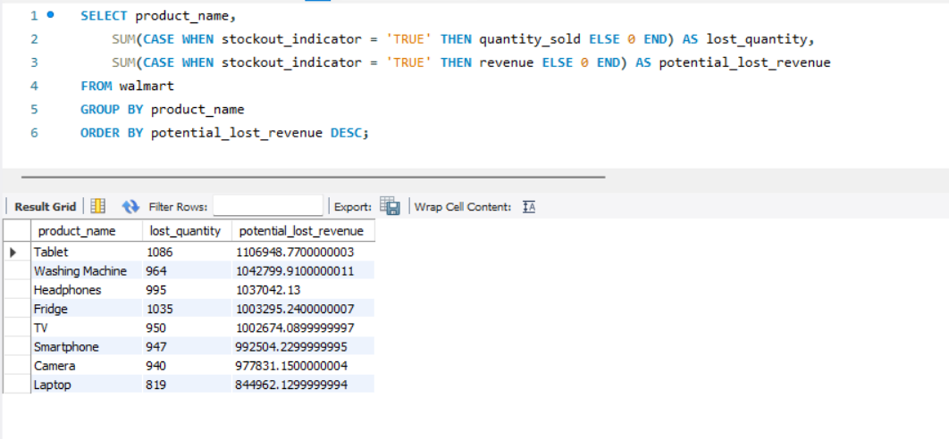

- Which products are critical to the business based on both high revenue contribution and frequent stockouts?
Insights: Some of the products generate substantial revenues and are also frequently out of stock. Such products are key to the business because they generate high demand and substantial revenue.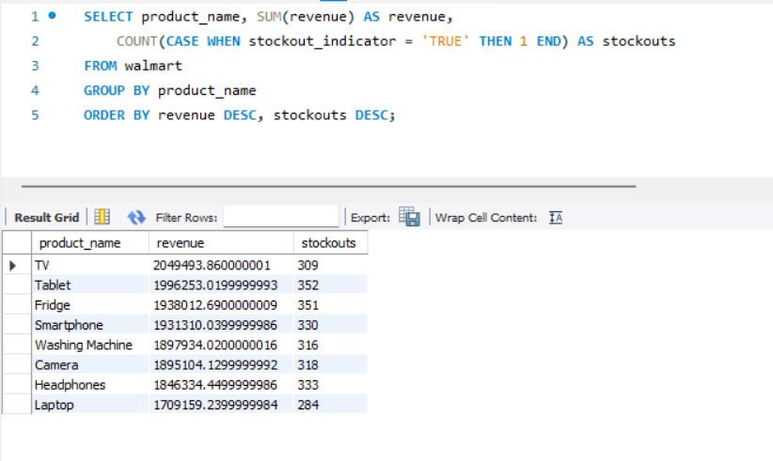

Recommendations:
- Apply demand forecasting for seasonality planning
- Enhance inventory levels of items with higher stockouts
- Develop optimal promotion plan with selective discounting
- Generate diverse income streams among all categories to avoid reliance
- Revamp supply chain management in top-performing zones

